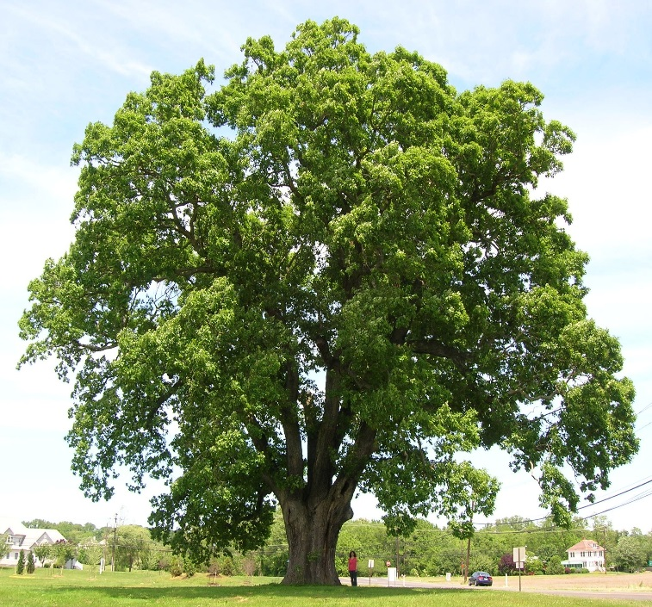Oak Class Autumn Curriculum Map
Maths - There will be reasoning and problem-solving focus for both year groups as well as calculation. We will recap and extend multiplication and division skills to enable the children to become as fluent as possible in these areas. We will be working on using the four operations, understanding place value and using fractions.

English - We will be looking at using complex, simple and compound sentences as well as learning how to add tension and interest in our writing to engage the reader. We will explore poetic devices such as extended metaphors and simile. We will study Victorian writers such as Dickens and study texts about the Victorians such as Tom’s Midnight Garden. We will be working really hard to extend our vocabulary. Our reading skills will include inference, deduction and fact finding.

Routine, regular work-arithmetic, times tables and spellings, as well as reading a variety of texts and developing inference and deduction skills in a comprehension context.
Science- We will be looking at the way electricity flows and experiment with conductors and non-conductors. Forces will be another area of study, looking at such areas as gravity and magnetism.
RE- Our topic this term will be Islam and the Christmas story. In PE, we will be using the Real PE syllabus to look at ball skills and team games. In IT, we will look at coding using scratch.

Spelling and grammar - learning the 5 and 6 statutory word list and looking at spelling patterns. We will also look at parts of a sentence and learn how to construct a variety of sentence types and sharpen our thesaurus skills! We will examine synonyms, antonyms, the subjunctive, relative clauses, modal verbs and adverbs.
DT- We will be looking at bridge design and finding out what makes a good bridge. In art we will be looking at portraits and Victorians artists such as William Morris, William Leighton Leitch and the work of Brunel.

PE
History – We will be looking at and reflecting on the changing power of the Monarchy and comparing rulers since Henry the Eighth.

