Mountains
The world's tallest mountain ranges form when pieces of Earth's crust—called plates—smash against each other in a process called plate tectonics, and buckle up like the hood of a car in a head-on collision. The Himalaya in Asia formed from one such massive wreck that started about 55 million years ago. Thirty of the world’s highest mountains are in the Himalaya. The summit of Mount Everest, at 29,035 feet (8,850 meters), is the highest point on Earth.
Types of mountains
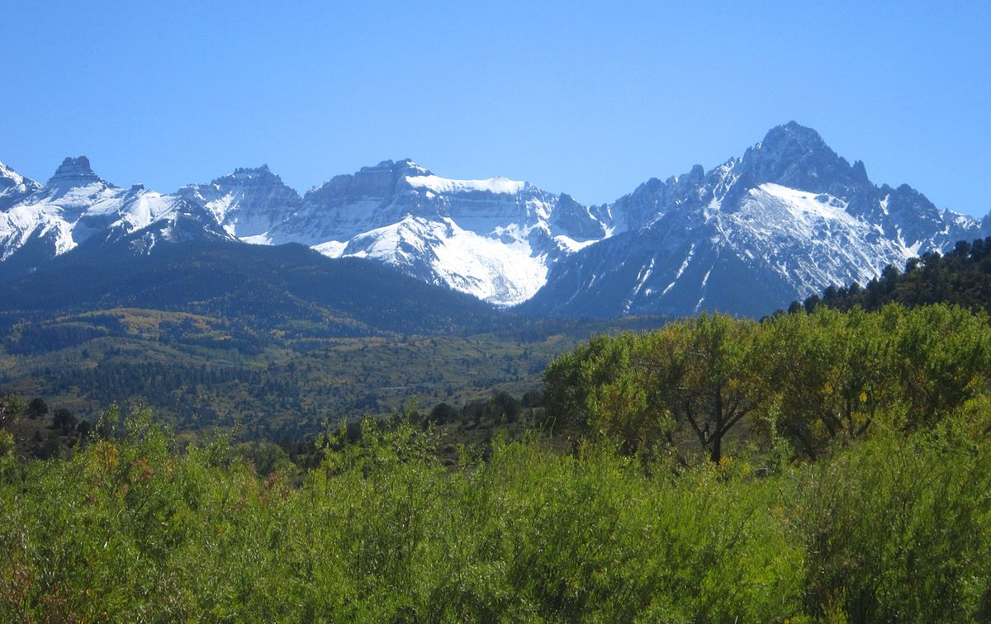
This Photo by Unknown Author is licensed under CC BY-SA
There are 5 different types of mountains: Fault block, folded, dome, volcanic and plateau.
Fault block
These mountains form when faults or cracks in the earth’s crust forces materials or blocks of rock up and others down. Instead of folding over, the earth’s crust fractures (pulls apart). It breaks up into blocks or chunks. Often the fault block mountains have a steep front side and a sloping back side. Examples of fault block mountains are the Sierra Nevada mountains in North America and the Harz in Germany.
Folded
The fold mountains are formed when two plates collide head on. They are the most common and have the largest mountain ranges. Fascinatingly fold mountains were formed millions of years ago! Some examples of the folded mountains are: Himalayan (Asia), Alps (Europe), Andes (south America), Rockies (North America) and the Urals (Russia).
Dome
Dome mountains are the result of a great amount of melted rock also known as magma, pushing its way under the earth’s crust. Without erupting onto the surface, magma pushes up overlaying rock layers as the dome is higher than its surroundings. At some point, the magma cools and forms hardened rock. The uplifted area created by rising magma is called a dome because of looking like the top half of a sphere (ball). The rock layers over the hardened magma are warped upward to form the dome. But the rock layers of the surrounding area remain flat.
Volcanic
As you have probably guessed volcanic mountains are formed by volcanos when magma deep within the earth erupts and piles upon the surface. Magma is called lava when it breaks through the earth’s crust. When the ash and lava cools, it builds a cone of rock. Rock and lava pile up layer on top of layer. Some examples of these are: Mount St. Helens (North America), Mount Pinatubo (Philippines), Mount Kea (Hawaii), Mount Lola (Hawaii).
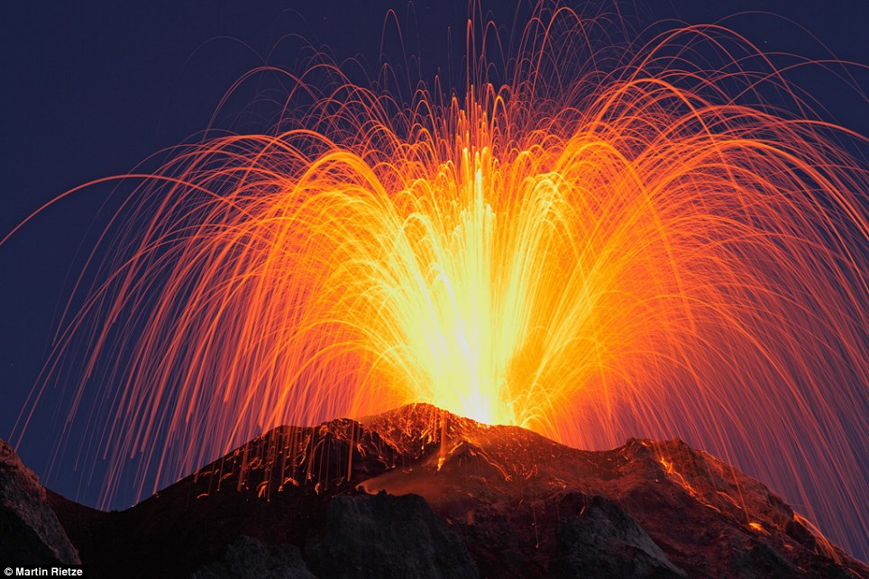

Plateau
Plateau mountains are not formed by internal activity. Instead these mountains are formed by erosion. Plateaus are large flat areas that have been pushed above sea level by forces within the earth or have been layers of lava. The mountains in New Zealand are examples of the Plateau mountains. Plateau mountains are often close to fold mountains.

