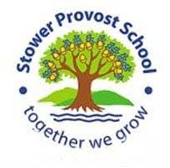

**Oracy** – in all subjects, children will be encouraged to speak with clarity and precision as well as giving evidence and justification for their views

**Oak Class Autumn Curriculum**

**Maths** - looking at calculation as well as reasoning in areas such as place value, Roman numerals, negative numbers, the four operations and fractions. The children will be encouraged to gain fluency in times tables and using known facts to make mathematical inferences. They will also be encouraged to speed up and improve their arithmetic.

**RE** - looking at the Islamic faith in detail and what it takes to be a good Muslim, as well as the Five Pillars. In PHSE the children will be setting personal and academic goals for this year.

**Spelling and grammar** - learning the 5 and 6 statutory word list and looking at spelling patterns including, for example, words ending in –ible and –able, -and -fer and homophones. We will also dip into the etymology of our language. We will learn to identify and use a variety of tenses, punctuation, synonyms, antonyms, modal verbs, as well as the subjunctive form.

**Pastoral care** – This will be very important this term and there will be a strong bias towards looking at and maintaining our mental health as much as possible in these challenging times, as well as maintaining and celebrating the children’s growth mind sets, study skills, critical thinking, independence and resilience.

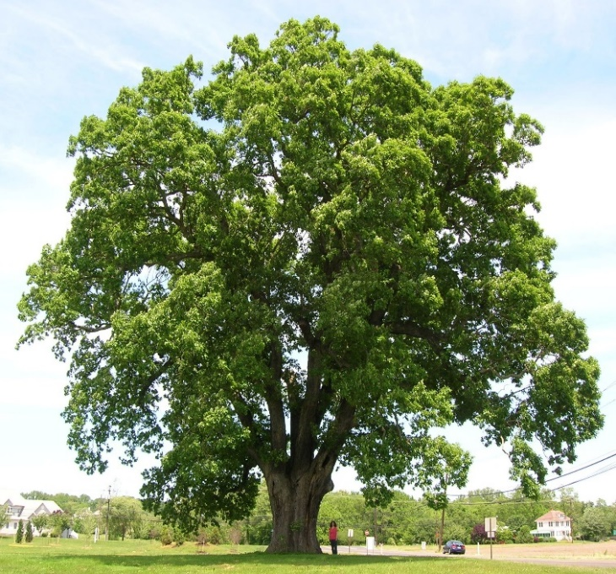

**History** – looking at various aspects of World War Two, in particular, the importance of the Battle of Britain in the ending of the war and the role of propaganda. We will critically examine evidence and examine its provenance.

**DT**- looking at the programmable controller ‘Crumble’ and using it to construct a rotating model of the solar system.

**Art** – looking at artists in war.

**Computing** – keeping ourselves safe when using the internet and making movies.

**Music**- learning to play accompaniments to ‘Happy’ and other songs.

PE

**English** - writing: looking at using complex, simple and compound sentences as well as learning how to add tension, dialogue and interest in our writing to engage the reader. We will explore poetic devices such as extended metaphors and similes as well as powerful descriptive phraseology. We will examine a variety of texts including *Dr. Maggie’s Guide to the Solar System* and *Goodnight Mr Tom*. We will also look at the resilience shown by figures such as Professor Stephen Hawking and NASA’s Katherine Johnson. Finally, we will look at both formal and informal persuasive and information texts. We will link these stories to our British Values.

Reading skills will include inference, deduction and fact finding as these are a major importance in effective comprehension.

**Science** - studying the earth and space, including our solar system, our galaxy and beyond. We will examine why celestial bodies are the shape they are, and how waves and energies behave in space. We will also look at our moon and the effect it has on our world. We will also critically examine how people have theorised about space. We will also be looking at light and the way it behaves.

**French** – learning to introduce ourselves, ask simple questions and talk about our families.

**Geography** - looking at and comparing physical and human geography of contrasting regions and why people choose to settle where they do. We will also consolidate our map reading skills, including 4 and 6 figure grid references.