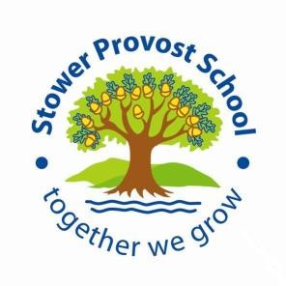
Equality Objectives

At Stower Provost Primary School, we are committed to ensuring equality of education and opportunity for all pupils, staff, parents, and carers, irrespective of race, gender, disability, belief, religion, or socio-economic background.

To further support pupils, raise standards and ensure inclusive teaching, we
have set the following objectives:

Objective 1:
To monitor and analyse pupil achievement by race, gender and disability and act on any trends or patterns in the data that require additional support for pupils.

Objective 2:
To raise levels of attainment in core subjects for vulnerable learners.

Objective 3:
To review levels of parental and pupil engagement in learning and school life, across all activities to ensure equity and fairness in access and engagement.

