Woodville, Stour Provost, Gillingham,
Dorset SP8 5LX
Telephone: 01747 838370
e-mail: office@stowerprovost.dorset.sch.uk
Website: www.stowerprovost.dorset.sch.uk
Headteacher: Ailsa Boardman-Hirst

SEND Information Report
Stower Provost Primary School’s Offer for Children with Special Educational Needs and / or Disabilities (SEND)
Stower Provost is a small, but expanding primary school in rural North Dorset. Our catchment includes the local villages of Stour Provost, Stour Row, East and West Stour, Buckhorn Weston and Kington Magna, but we attract children from a much wider area including Marnhull, Gillingham, Shaftesbury and Sturminster Newton.

We treat every child as an individual, a special person, and aim to be fully inclusive, meeting the needs of all children (including those with Special Educational needs and Disabilities) within our mainstream setting through quality first teaching.

The Code of Practice 2015 states that:
‘A pupil has SEN where their learning difficulty or disability calls for special educational provision, namely provision different from or additional to that normally available to pupils of the same age.’
The Four broad areas of need identified within the SEN Code of Practice 2015 are:
- Communication and Interaction (e.g. speech articulation, stammering, speech and language delay, autism)
- Cognition and Learning (e.g. global learning difficulties, dyslexia, dyscalculia etc)
- Social, Emotional and Mental Health Difficulties (e.g. anxiety, depression, eating disorders obsessive, compulsive disorder (OCD) etc)
- Sensory and Physical Needs (Visual impairment, hearing impairment, physical disability)

Special Educational Needs staff and contact details
Head teacher – Mrs Ailsa Boardman-Hirst
SENDCo – Miss Amanda Solman
ELSA –Miss Josie Stone

What types of Special Educational Needs and Disabilities do we provide for?
We aim to be a fully inclusive school. The table below sets out the four broad areas of need and examples of the types of intervention and support we put in place, as a school, to support them.
Area of need | Examples of support in our school | How we check the support is working.
Communication and Interaction  This is where a pupil has difficulty communicating with others. This may be because they have difficulty saying what they want to, understanding what is being said to them or they do not understand or use social rules for communication. | Quality first teaching will ensure additional check ins, visual prompts and reminders, visual timetables – as well as additional transition support. In addition we work closely with the speech and language therapy services and deliver personalised programmes, we offer ELSA support and we offer groups to support communication needs eg. Social thinking, TalkAbout | Interventions and support will be evaluated through lesson observations, learning walks, teacher assessment, parent views, pupil views and external assessments.
Cognition and learning  This is when a pupil learns at a slower pace than others in their class. It may be that they have a low reading or comprehension age. This also includes conditions such as dyslexia, dyscalculia and dyspraxia. | Differentiation through quality first teaching, in class support, some small teaching groups and small group English and maths support – as well as additional transition support. Individual English and maths support may be available. We offer evidence based interventions to support English and Maths progress. We work closely with our Specialist teacher and Educational Psychologist who may make recommendations in how we best ensure progress. | Interventions will be evaluated through lesson observations, learning walks, teacher assessments, parent views and pupil views.
Social, emotional and mental health difficulties.  These difficulties may include becoming withdrawn or isolated, as well as displaying challenging behaviour. These behaviours may reflect underlying mental health difficulties such as anxiety and depression, self-harming, eating disorders or substance abuse. Other children or young people may have disorders such as attention deficit disorder, attention deficit hyperactive disorder or attachment disorder. | Differentiation through quality first teaching, in class support and some small teaching groups. We would think carefully about environment, seating arrangements, movement breaks and ensure additional transition support. We may write a positive behaviour plan. We offer ELSA and ‘nurture’ provision. We work closely with outside agencies, such as specialist teachers, educational psychologists and paediatricians. | Interventions will be evaluated through lesson observations, learning walks, teacher assessment, parent views, pupil views, external assessments, attendance data and behaviour data.
Sensory and/or physical needs This when a pupil has a disability that hinders then from using the educational facilities generally provided, such as visual, hearing or multi-sensory impairment. | Support tends to be very personalised. We work closely with outside advisors, such as vision impairment team, to ensure that we make adjustments and put provision in place, to ensure that children can fully access our curriculum and thrive in their primary school life. | Interventions will be evaluated through lesson observations, learning walks, teacher assessment, parent views, pupils views and external assessments. Support teams from county will conduct regular reviews.

How do we consult pupils with SEND and involve them in their education?
SEND pupils are included as part of the individual support plan process/meetings and their thoughts and feelings are considered and recorded. As a small school we get to know the children very well and it is very important to us that the child’s voice is heard.
What specialist services and expertise are available at or accessed by setting/school/college?
The SENDCo Miss Amanda Solman has held this role in a number of schools for many years, keeping herself informed of changes in legislation and of best current practice. She has completed The National Award for SENCOs and a PG Cert in Dyslexia and Literacy. Miss Stone has completed her ELSA (Emotional Literacy Support Assistant) training which will enable her to regularly support and nurture children with social, emotional and mental health issues.
The school has access to a number of specialist services, whom we call upon when the need arises. We regularly work with the Educational Psychologists (EP), Specialist Teachers from Dorset County Council, Speech and Language Therapists, Paediatricians, Occupational Health. We also have a school nurse with whom appointments can be made. We also work closely with other schools who may have expertise in a particular area.
How do we identify and assess special educational needs and disabilities and how do we plan and review support?
At Stower Provost we aim for early identification of special educational needs and disabilities, so our assessment process begins as soon as a child starts our school. School staff use a wide range of tools to assess and will quickly respond if they identify a need or difficulty. We will also work closely with any previous educational settings, who may be able to share information. Sometimes a child may have a gap in their learning which is slowing progress, which we can quickly address. Alternatively there may be an on-going special educational need, which is likely to need support which is ‘different from’ or ‘in addition to’ other children of their age.
We closely follow, Dorset’s Graduated Approach (described below) which ensures that as a school we can respond swiftly and effectively to support our children. At each stage parents and carers will be informed and their understanding and knowledge of their child sought.
From Dorset County Council’s Graduated Approach Document:
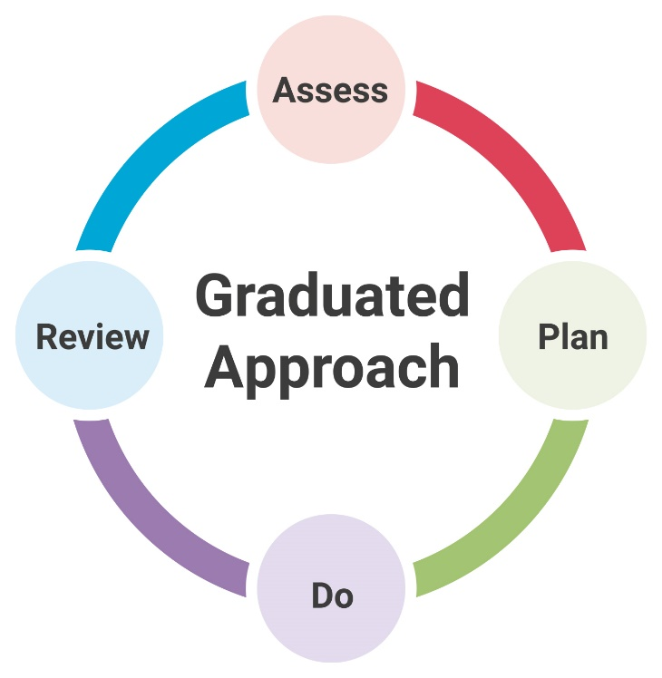
The graduated approach starts at the whole-school/setting level. Teachers are continually assessing, planning, implementing and reviewing their approach to teaching. However, where a potential special educational need has been identified, this cyclical process becomes increasingly personalised: Individualised assessment leads to a growing understanding of the barriers to and gaps in learning. Continual reflection on approaches to meeting the needs leads to a growing understanding of strategies which enable the child to make good progress and achieve good outcomes.

Assess: In the ‘assess’ stage of the graduated approach teachers/practitioners gain a growing understanding of a child’s needs to enable us to:
• planning effective teaching
• determining appropriate provision
• informing adjustments to teaching that will lead to good progress and improved outcomes for CYP.
Plan
In the ‘plan’ stage of the graduated approach teachers/practitioners gain a growing understanding of what teaching approaches work. For children requiring SEN support, there are two areas that need to be considered when planning provision:
• High-quality teaching and learning
• Targeted provision.
Once the need for SEN support has been identified, the first step in responding to identified needs is to ensure that high-quality teaching, differentiated, is in place. Targeted provision is provision that is additional to or different from that made for the majority of children in school. One of the key themes from the SEND Code of Practice is the need to ensure that where additional/different targeted provision is planned for, there are clear and expected outcomes linked directly to the provision.
Do
In the ‘do’ stage of the graduated approach teachers the intervention and support is in place.
Review
In the ‘review’ stage of the graduated approach teachers/practitioners gain a growing understanding of what approaches secure better outcomes. It is not necessary for teachers/practitioners to wait for formal review meetings before reviewing and, if appropriate, making changes to teaching approaches and other provision. However, the SEND Code of Practice states that progress towards meeting planned outcomes should be tracked and reviewed at least once a term. The outcomes of the review should feed directly into the next planning phase of the graduated approach.
How do we measure the progress being made by our pupils with SEND? And how do we know our support works?
At Stower Provost Community school we have assessment procedures to ensure we are keeping track of pupils progress throughout their time with us. Pupils progress is measured each half term against national benchmarks. In addition, it is often appropriate to use tools which can measure smaller steps of progress – this may be against personal targets or outcomes described on the child’s support plan.
Parents will be invited into the school three times a year to talk about their child’s progress. If your child has more complex needs, then we may review a pupil’s progress through a Person Centred Review. This approach very much values the views the pupil and the parents as well as the schools.
Sometimes we involve outside agencies to support us in making our assessments and theses agencies can also offer advice the parents.
We also evaluate the quality of our provision each half term. We may analyse the following:
- Assessment grades given to pupils by staff against national benchmarks.
- Teacher assessment data.
- Attendance data.
- Behaviour records.
- Observations of children
- Parents and pupils voice.
- Reading and spelling assessments.
- Lesson observations and learning walks.
- Work scrutiny.
Interventions will be formally evaluated termly, to ensure that pupils are making progress. Though, all children’s progress and outcomes are assessed on an on-going basis. The impact of interventions will be assessed using a variety of methods such as teacher assessment, pupil and parent feedback, reading assessments, spelling assessments, learning walks and lesson observations. Interventions will be adapted and changed if a pupil is not making progress – or we may seek advice from outside agencies.

How do we support pupils with SEND through transition?
Stower Provost Community School works with early years settings, secondary schools and other settings to support pupils through transition from one educational setting to another.
We will work with the SENDCo and other staff from your child’s previous setting to ensure that we understand your child’s needs and can plan for them when they move to us. Sometimes we will attend annual review meetings and meetings with other agencies at a pupil’s previous setting to help us to gather all the relevant information. We can also arrange extra visits to Stower Provost Community School to help with your child’s transition. We will provide photographs of key areas of the school and members of staff to pupils who require them in order to facilitate a smooth transition to Stower Provost Community School. We can also provide extra transition activities and time for children as they move from one class to another, if necessary.
Parents may also wish to make an appointment to meet our SENDCo to discuss their child’s needs and have a tour of the school.
As children move to secondary school, we work very closely with the SENDCo and other staff at the receiving schools. We can arrange additional transition days, if this is helpful in preparing our young people for the move.

How do we ensure that pupils with SEND are not treated less favourably?
- The Senior Management Team, the SENDCo and other subject leaders undertake learning walks and on-going day to day assessment of the school.
- Lesson observations
- The work of pupils is scrutinised and moderated
- Analysis of various data, such as teacher assessment grades, attendance and behaviour information.
- Meetings with pupils and parents
- SENDCo ensures that we SEN need and provision maintains a high profile in our school priorities.
- We will monitor extra-curricular information
- We will liaise with external agencies
- Have an accessibility plan in place as required by a particular individual
- Implement reasonable adjustments
- We understand that equality of provision does not mean that every child has the same, but rather that every child has what they need.

What support will there be for my child’s/young person’s overall well-being?
As a small school, each child is well known to all staff, which means that staff keep a check on overall well-being of all our children and can quickly identify any difficulties or challenges.
Stower Provost Community School recognises that the welfare of the pupil is paramount and takes seriously its responsibility to safeguard and promote the welfare of the children and young people in its care. All staff are aware of their role in this vital area of school life and the absolute need to contact Mrs Boardman-Hirst the Designated Safeguarding Lead or Miss Gale the Deputy Safeguarding Lead, with any concerns at all.

What training are the staff supporting children and young people with SEND have had or are having?
Regular safeguarding training for all teaching and non-teaching staff is a priority at Stower Provost Community School. All staff have access to Continued Professional Development (CPD) courses run by Dorset Council and courses relevant to the needs of current SEND pupils in the school are often attended. On occasion, we have external agencies come in to school to deliver training on areas of particular interest or need at the time.
Recent training undertaken in our school includes: Supporting children with Autism, Developing Ambitious Outcomes, Supporting reading, Introduction to Dyslexia, Developing Independence in our Leaners, Supporting Hearing Impairment, ELSA supervision, Precision teaching, Positive behaviour management, Strategies to support sensory processing, Epipen training, First Aid training.
Whenever the need arises staff will receive future appropriate training.
How will my child/young person be included in activities outside this classroom including school trips?
We make every adjustment possible to ensure that our SEND children join their peers on educational trips and residential journeys. On some occasions we have provided extra school staff on the trip, on others we have invited parents along to support their child. Parents are always contacted to discuss the most suitable arrangements for their child. A risk assessment is conducted prior to any off site activity to ensure everyone’s health and safety will not be compromised. In the unlikely event that is it considered unsafe for a child to take part in an activity, then alternative activities, which cover the same curriculum areas, will be provided in school. External providers will be advised of any particular need prior to a visit.
How will the curriculum be matched to my child’s or young person’s needs?
Throughout the school, teachers use a wide range of strategies and resources to differentiate the curriculum so that it best meets the needs of all of the pupils in their class. We understand the importance of high quality class teaching – all children make good progress when teaching is good. In addition to excellent teachers an important resource is our team of experienced and dedicated support staff, which allows us to provide small group support or extension activities within every classroom, every day.
The specific targets or outcomes that a child with SEND may be working towards, will be worked on in the mainstream classroom, but we are also able to offer personalised one to one or small group sessions, led by trained and very experienced support staff, and overseen by the SENDCo. We aim for these interventions to be little and often. Perhaps 10-15 minutes each day. This ensure children are getting plenty of time to practice, without missing out on their lessons and classroom activities. We plan carefully so that children don’t always miss the same session each week and that children do not miss out on a favourite lesson.
How are parents involved in the setting/school/college? How can I be involved?
Stower Provost Community School has the advantage of being a small village school and its ‘open door’ policy gives it a reputation for being friendly and welcoming. We recognise the importance of a strong partnership between home and school and work hard to make it easy for you to be a part of your child’s school life. You can always make contact with your child’s class teacher, the SENDCo or the head teacher by contacting the school office by telephone (01747 838370) or email (office@stowerprovost.dorset.sch.uk), or through dropping into the school in person.
How do we deal with complaints by a parent of a student with SEND or by a student with SEND?
We will always work closely with you to try and solve any worries or complaints you may have about your child. If you are not entirely happy you should contact the SENDCo who will work with you to resolve the issue. For further information please see our complaints policy which is outlined on our website.
How does the governing body involve other people in meeting the needs of students with SEND including support for their families?
The governing body has a duty to ensure that Stower Provost Community School adheres to the SEND Code of practice under the Children & Families Act 2014. This means that the school governors hold the Head teacher, Mrs A Boardman-Hirst and the SENDCo, Miss Solman, to account.
The governing body appoints a governor who is specifically responsible for Special Educational Needs and Disabilities (SEND). Our SEND governor is Mrs C Heasman. She ensures that the school and the SENDCo carry out their duties.
One of the key responsibilities of the governing body is to make sure that the Stower Provost Community School’s policy for students with SEND is published on the school website. This information must be reviewed annually by the governing body. The governing body also has a responsibility to ensure that appropriate safeguarding procedures are in place for all students, including those with SEND. You can find these policies on our school website.
The governing body, through the SENDCo, ensures that other appropriate agencies are involved in meeting the needs of students with SEND. The governing body are reported to regarding the number of pupils and their additional needs. We will ask your permission if we think your child would benefit from working with an outside agency. The content of the meeting is confidential and is only shared with parents, the SENDCo and relevant members of staff. Please speak to Miss Solman (SENDCo) if you require more information.
What provision is there for students who are looked after by the authority and have SEND?
The main contact for students who are looked after by the authority is Mrs Ailsa Boardman-Hirst (Head teacher). Pupils who are looked after by the authority and have SEND will have joint reviews so that all agencies are working together for the best outcomes for our pupils.
How is the learning environment adapted for pupils with SEND?
Part of the school has been furnished with specially adapted acoustics, carpets etc to assist children with hearing support requirements. Unfortunately, due to the age of the school building, wheelchair access is not possible in certain parts of the school, and while there is a disabled toilet accessible from the playground, there is no such facility in the main building. There are changing facilities for any child whose needs necessitate personal care.

Should you require any further information regarding Dorset Council’s offer with regards to SEND please access the following website - https://www.dorsetforyou.gov.uk/childrens/sen-disability/local-offer.

