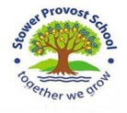

**Science – We will be looking at the way we classify living things by using our taxanomic skills using the Linnaean system:** **domain,kingdom,phylum ,class,order,family,genus and species – perhaps even subspecies! We will be examining microorganisims and think about how they can be helpful and harmful. We will make bread to see microorganisms at work.**

**We will also look at and describe the changes in us as humans develop form birth to old age. We will include the vital science skills of recording data and extrapolating trends as well as making predictions about our experiments.**

**RE – We will consider if belief in Akhirah (life after death) helps Muslims lead good lives as well as exploring other aspects of life as a Muslim.**

**Computing- we will be using scratch to create programs, and then revise and consolidate work from this year.**

DT – We will making our own version of a Dorset tapestry.

**CURRICULUM MAP OAK CLASS SUMMER 2023 2020**

**Maths – We will exploring 2d and 3d shape, statistics, ratio and timetables. We will also use our arithmetic and computational knowledge and applying those topics in problem solving and reasoning contexts. The children will continue to develop their multiplication and division skills and use known facts to help them predict patterns**.

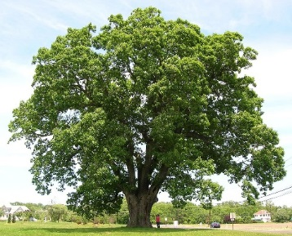

**Transition – we will consolidate the skills and attitudes which will promote a smooth and successful transition to year 6 and year 7.**

**English – We will be revising and creating a variety of text types including writing a balanced argument, narrative descriptions, instructions and explanations. In grammar we will be looking at standard and non-standard English and to revise and consolidate ways to improve sentences. In comprehension – We will be looking at the Greek myths as well as a variety of stand-alone texts to revise methods of answering questions with evidence. We will also be using the Ancient Greeks to study non-fiction texts.**

**Music – Using the composition 'The Little Train of the Caipira' as a focus. The children will explore rhythm and timbre as well as developing their recall of sounds with increasing accuracy. They will also be composing a piece of music and performing as an ensemble.**

**PHSE- We will be looking at exploring relationships as well as revising our British Values.**

**PE –We will practise our netball, swimming and athletic skills.**

**French -We explore different countries and forms of transport, then turn our attention to holiday destinations and develop conversational skills. The topic culminates with the children producing a travel brochure for their chosen destination.**

**Reading – We will be using our inference, deduction and other comprehension skills as well as retrieving information from a variety of texts including Percy Jackson and the Lightning Thief, Greek Myths and Who Let the Gods Out?**

**Oracy – The children will be encouraged to speak clearly and with confidence when explaining or debating and to give evidence for their opinions.**

**History – We will look at what the Greek legacy is, and how it has changed our lives. In addition, we will look at studying our local area in geography – and comparing it to a village in modern day Greece**.

**Art – We will be looking at ancient Greek art and producing and evaluating our own paintings, patterns, sculptures and mosaics.**