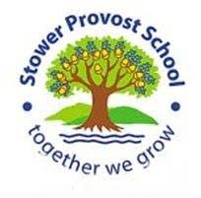



Maths - looking at calculation as well as reasoning in areas such as place value, Roman numerals, negative numbers, the four operations and fractions. The children will be encouraged to gain fluency in times tables, and using known facts to make mathematical inferences. They will also be encouraged to speed up and improve their arithmetic.

**Oak Class Autumn Curriculum 2022**

English - writing: looking at using complex, simple and compound sentences as well as learning how to add tension, dialogue and interest in our writing to engage the reader. We will explore poetic devices such as extended metaphors and similes as well as powerful descriptive phraseology. We will a variety of texts including *Dr. Maggie’s Guide to the Solar System,* the biography of *Katherine Johnson,* and *Hidden Figures.* We will also look at the resilience shown by figures such as Professor Stephen Hawking and NASA’s Mary Jackson and Dorothy Vaughan.. We will link and compare these themes with our British Values.

Reading skills will include inference, deduction and fact finding as these are a major importance in effective comprehension.

Oracy – in all subjects, children will be encouraged to speak with clarity and precision and giving evidence and justification for their views.

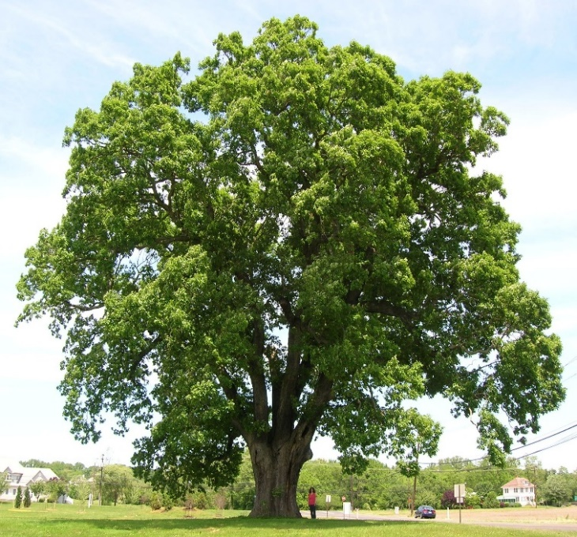

Spelling and grammar - learning the 5 and 6 statutory word list and looking at spelling patterns including, for example, words ending in –ible and –able, -fer and homophones as well as the etymology of our language. We will also look at and learn to identify and use a variety of tenses, punctuation, synonyms, antonyms, modal verbs, as well as the subjunctive form. We will use the Read, Write Inc scheme to help us with our spelling and reading, too.

French – learning to introduce ourselves, ask simple questions and talk about our families.

Pastoral care – This will be very important this term and there will be a strong bias towards looking at and maintaining our mental health as well as maintaining and celebrating our growth mind sets, study skills, critical thinking, learner independence and resilience. We will continue to explore our Commonwealth characters – Ripples the River Turtle (resilience), Harriet Hammerhead (hope and optimism), Sam Sea Otter (self worth), Rosie Red Panda (relationships) 4) Steven the sting ray (self-care).

History – Looking at the development of the Shang Dynasty as well as the religious, cultural and everyday life of Shang people. We will also think about what a civilisaton is and explore what inferences we can make about the past using artefacts.

Science - looking at the earth and space, including our solar system, our galaxy and beyond. We will examine why celestial bodies are the shape they are, and how waves and energies behave in space. We will also look at our moon and the effect it has on our world. We will also critically examine how we have theorised about space. We will also examine simple machines and gravity, mass and weight.

Geography - looking at and comparing some aspects of physical and human geography of contrasting regions and why people choose to settle where they do. We will also consolidate our map reading skills, including 4 and 6 figure grid references.

RE-Oak class will be looking at Buddhism and Dharma. We will discuss the Eight Fold Path and the Middle Way.

DT – Looking at pneumatics and making our own moving monsters.

Art – Looking at tints and shades as well as using perspectives.

Computing – keeping ourselves safe when using the internet and making movies.

Music- learning to sing and critique ‘Livin’ On A Prayer’ and playing some classroom Samba jazz with improvisations.

PE