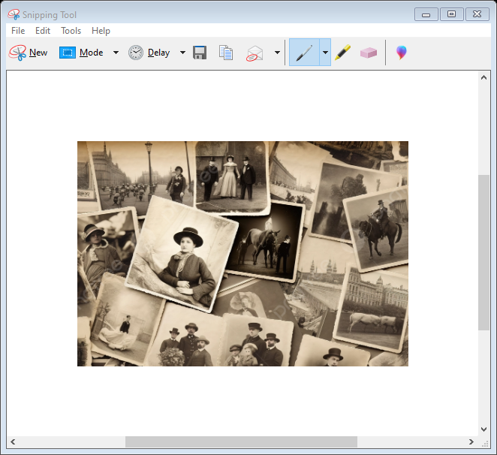

Year 1 Art

The children will learn about the concept of the portrait and how the collage technique can be used to make a portrait.

**Hazel Class**

**Autumn 2 2023-2024**

Year 1 Science

The children will learn that objects are made from materials. They will identify a range of everyday materials and their sources. Children will investigate the properties of materials and begin to recognise that a material's properties define its use.

Year 1 / EYFS English

The children will learn about autobiographies, non-chronological reports and riddles with the support of a wide range of engaging fiction and non-fiction stories.

Year 1 History

The children will learn about everyday life and families today, including comparisons with childhood in the 1950s, using artefacts and a range of different sources.

EYFS Maths

The children will learn about:

Match, sort and compare

Talk about measure and patterns

It’s me 1, 2, 3

Circles and Triangles

1, 2, 3, 4, 5

Shapes with 4 sides

Year 1 Maths

The children will learn about:

Place Value within 10

Addition and Subtraction within 10

Shape

Year 1 / EYFS RE

The children will learn about Hanukkah, which is the Jewish Festival of Lights that is celebrated every autumn in November or December. The children will learn about the miracle of the lamp.

Year 1 / EYFS PSHE

The children will be learning to identify similarities and differences between people in their class, be able to tell you what bullying is and know some people who they could talk to if they were feeling unhappy or being bullied. They will learn how to make new friends.

EYFS Expressive Art and Design

The children will be working together to build structures using various resources and construction kits. They will look at existing products to inspire their ideas. The children will use a range of resources to create artwork of their faces. They will be introduced to painting and drawing techniques.

EYFS Understanding the World

The children will explore and begin to learn about their immediate environment. They create sketch maps to represent real and imaginary journeys, and use Google maps to explore their local area. They explore physical features in their local environment using photographs, and explore the changes that happen to the local environment in autumn. They use world maps and globes to identify the UK and make comparisons with other locations, and they will look at photographs to see how the local environment has changed over time. They are introduced to positional language such as under, over, above, below, through and next to.

The children will talk about events in their lives and lives of family members, use story books to find out about life in the past and make comparisons with their lives. They will be introduced to vocabulary related to time and order familiar events.

The children will be introduced to vocabulary related to senses, beginning to name and locate parts of the body. They will explore similarities and differences between themselves and their friends, and begin to conduct tests and use language such as then and next to explain the results.

The children will learn to explore, name and sort materials according to their properties. They will be introduced to vocabulary such as soft, smooth, rough, light and heavy, and they will explore reflective, waterproof and magnetic materials.

Year 1 D&T

The children will learn about the purpose of shelters and their materials. They will name and describe shelters and design and make shelter prototypes. Children will then design and build a play den as a group and evaluate their completed product.